**Step1** : Extract the zip file

*cloudera-quickstart-vm-5.13.0-0-virtualbox.zip* in a new folder for e.g. **F:\Cloudera**

Step2: After extraction follow the steps:

Download Virtualbox Manager from the following link

<https://www.virtualbox.org/wiki/Downloads>

Click on Windows hosts(Windows machine) OR OS X hosts(for mac machines)

After installation follow the below steps

open oracle vm virtualbox->click Machine Menu-> New

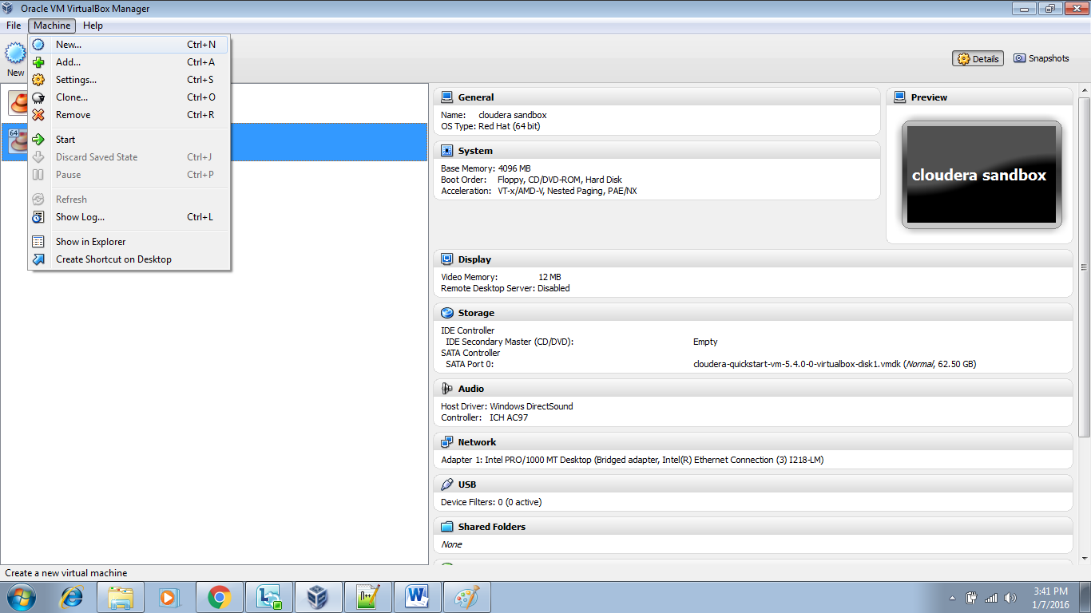

Enter the Name of your Machine(Your Choice)

Select “Linux” in OS Type

In version Select “Red Hat(64 bit)”

Click Next.

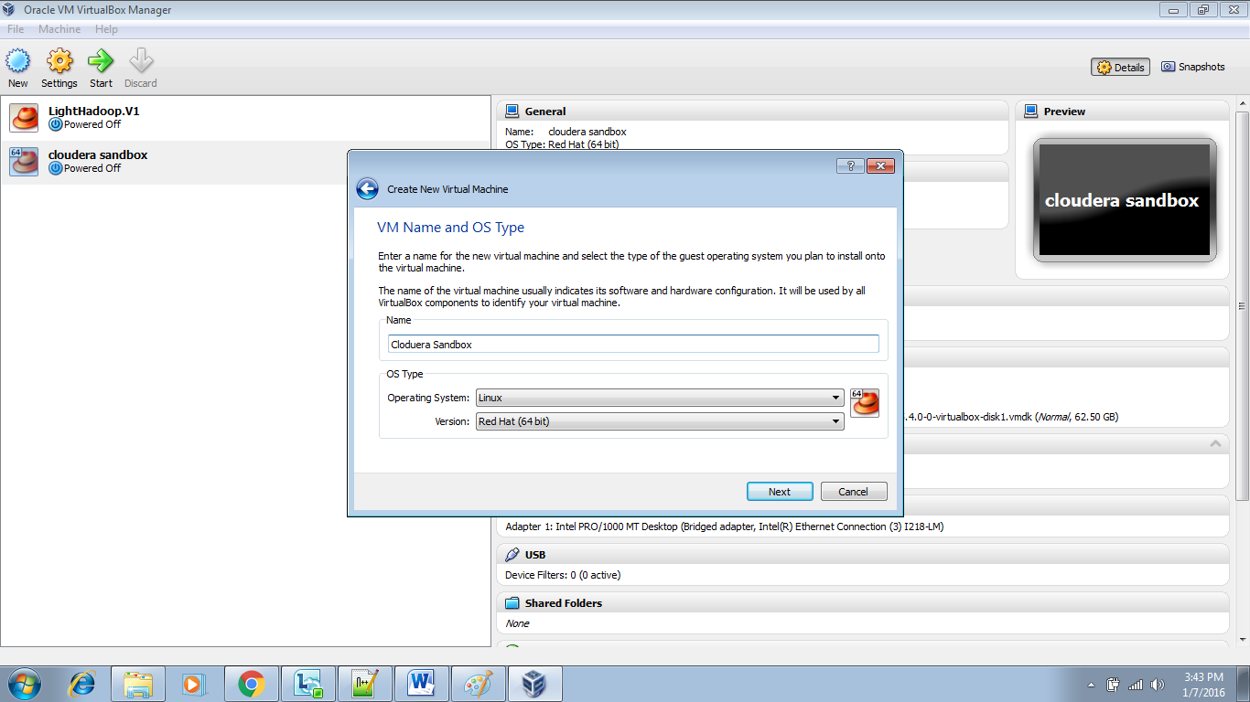

Allocate the RAM for this VM.

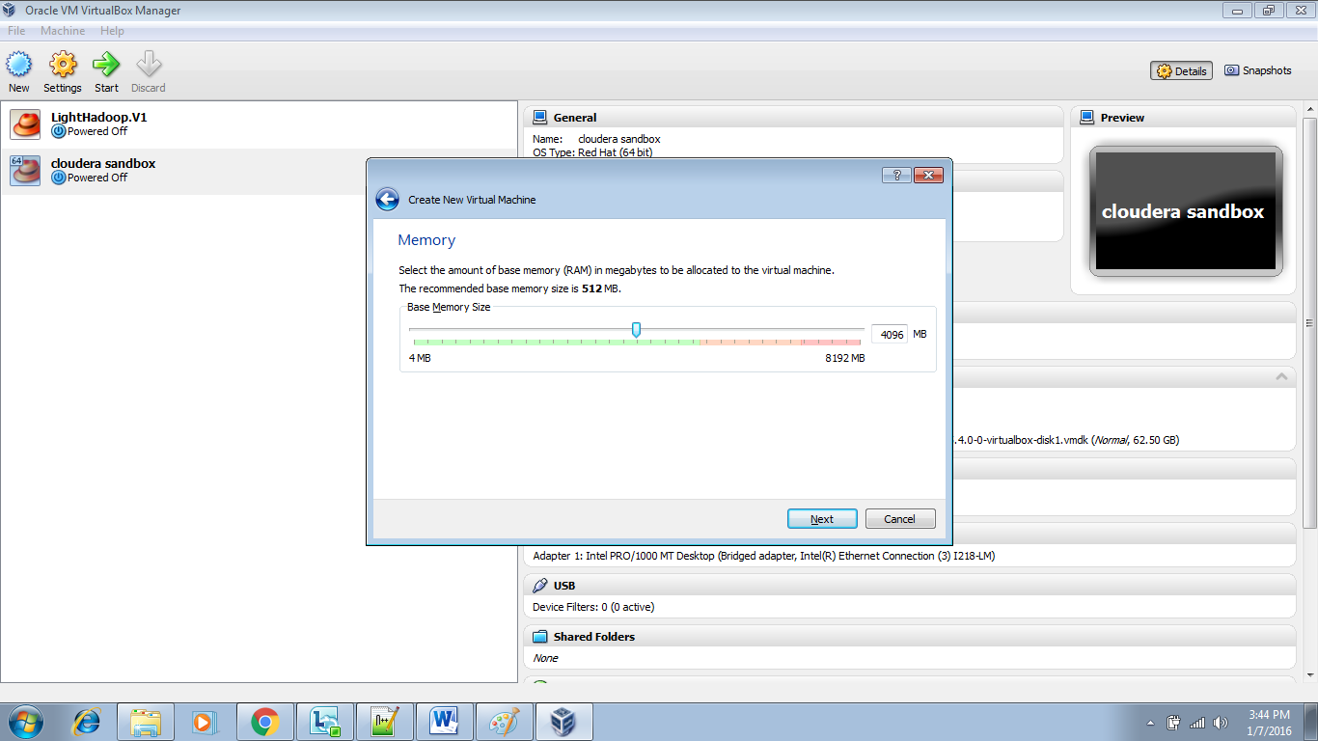

“Choose existing hard disk” so image and the data will be created on top your existing Hard Drive.

Select/Browse the downloaded Cloudera quick start VM image.

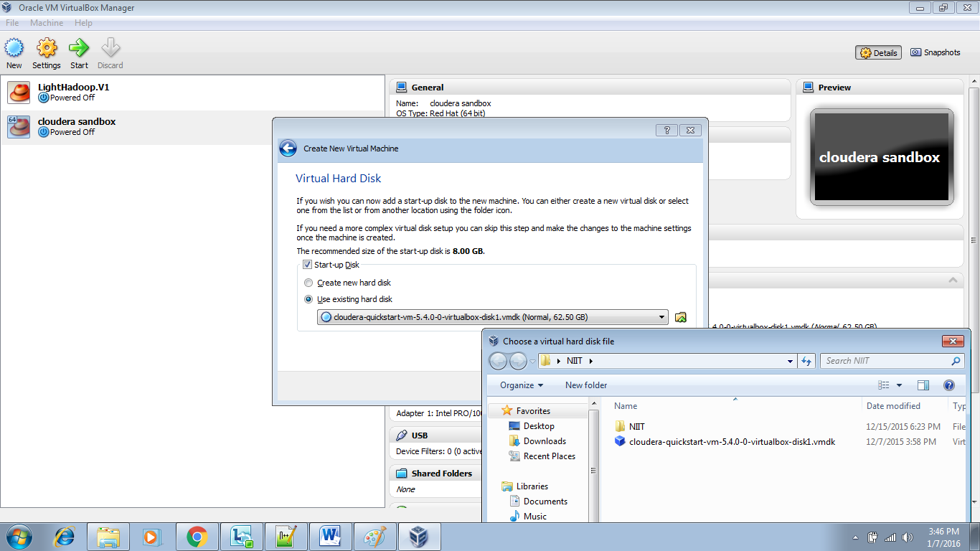

Click On Create.

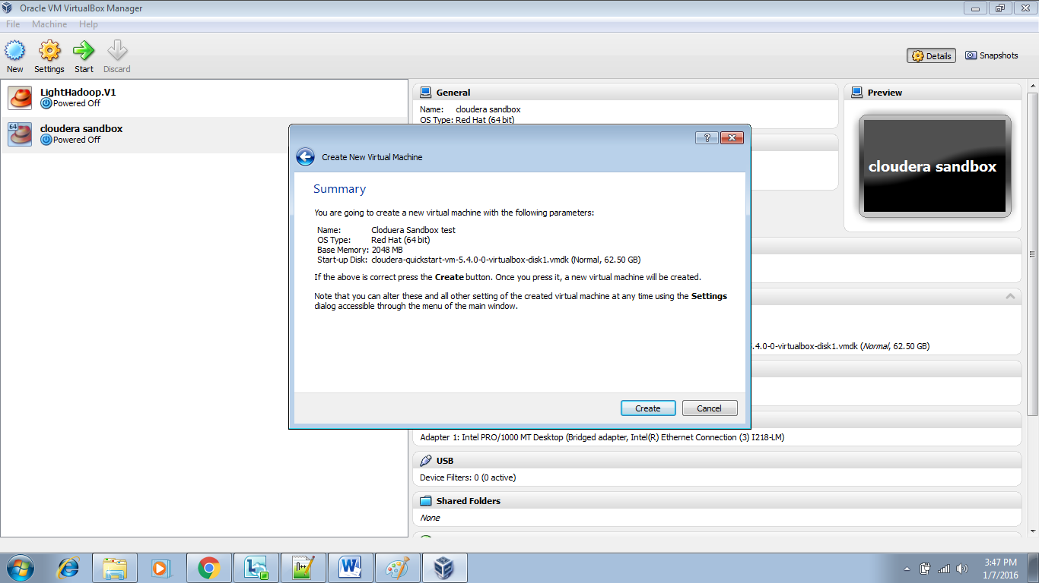

Now select the created VM and click on start.

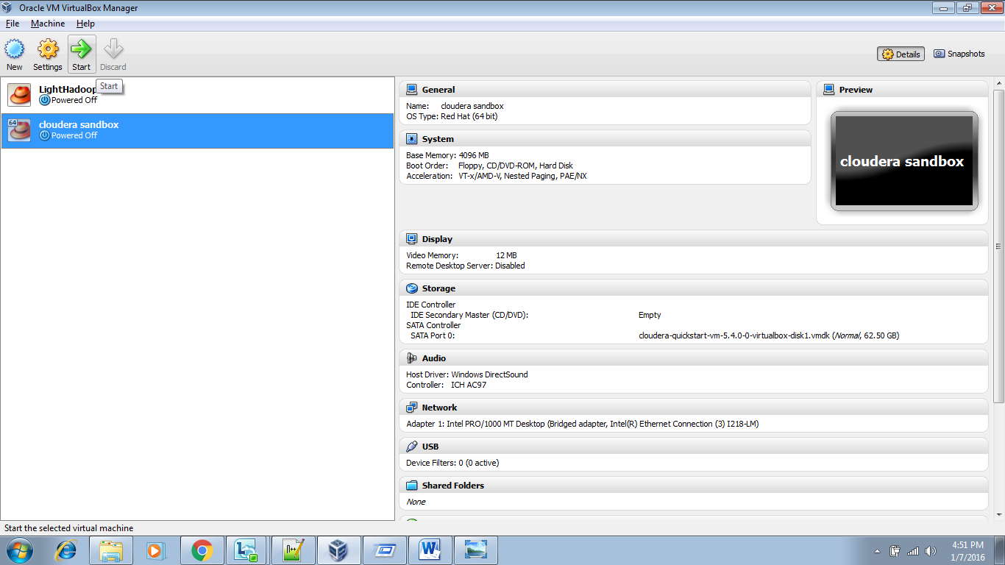

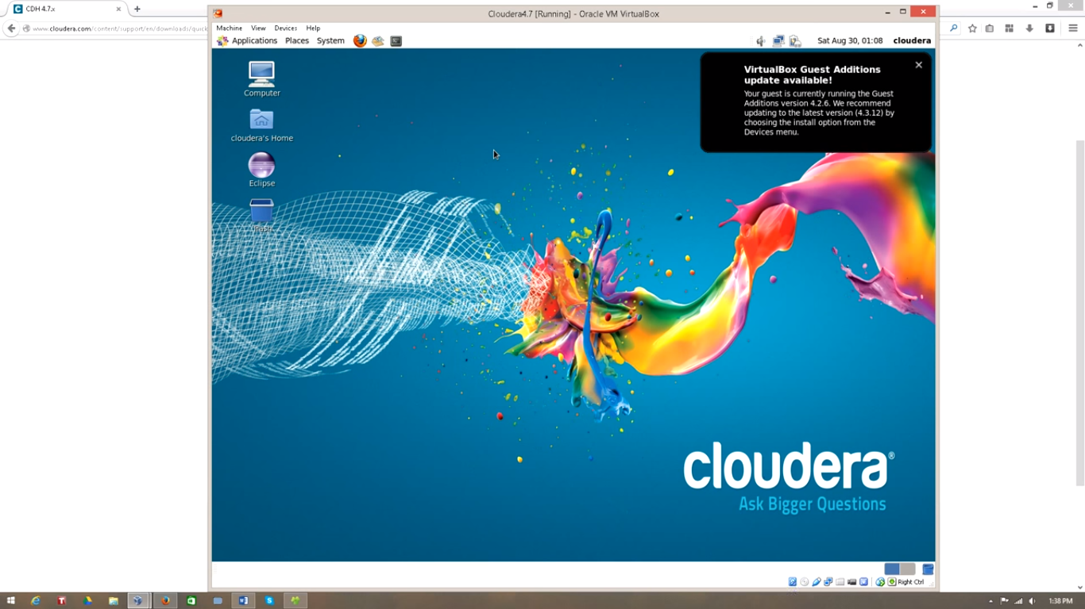

We are Done ☺